Feature Engineering Techniques – 1-Page Summary Report

Problem Statement
Raw applicant attributes (income, debt, age, employment, credit limits, …) are rarely optimal inputs for a credit-scoring or probability-of-default model. Feature engineering turns those raw fields into ratios, scaled variables, bins, encodings and interactions that carry clearer signal and behave better for linear and tree-based models.

Solution Strategy
- Create a small but realistic synthetic credit portfolio with controlled missingness.
- Derive classic domain features: DTI, utilisation, log-income, credit age.
- Apply numerical transforms: standard / min-max scaling and quantile / custom binning.
- Encode the categorical employment variable (one-hot, ordinal, simple target encoding).
- Add interaction and polynomial terms that domain experts often find useful.
- Flag missing values and perform simple median / mode imputation.
- Assemble a final numeric feature matrix and inspect correlations with default.
- Provide a simulation that lets the user change bin count, scaling method and interactions.

Solution
On a 40-applicant synthetic book the engineered features show clear relationships with default (utilisation², employment encoding and missingness indicators rank among the strongest). Default rate rises from 0 % in the lowest DTI bin to ~40 % in the highest bins. A high-utilisation flag (utilisation > 0.7) doubles the observed default rate (20 % → 50 %). Scaling produces well-centred distributions ready for regularised models; binning creates monotonic risk segments that are easy to explain to credit committees.
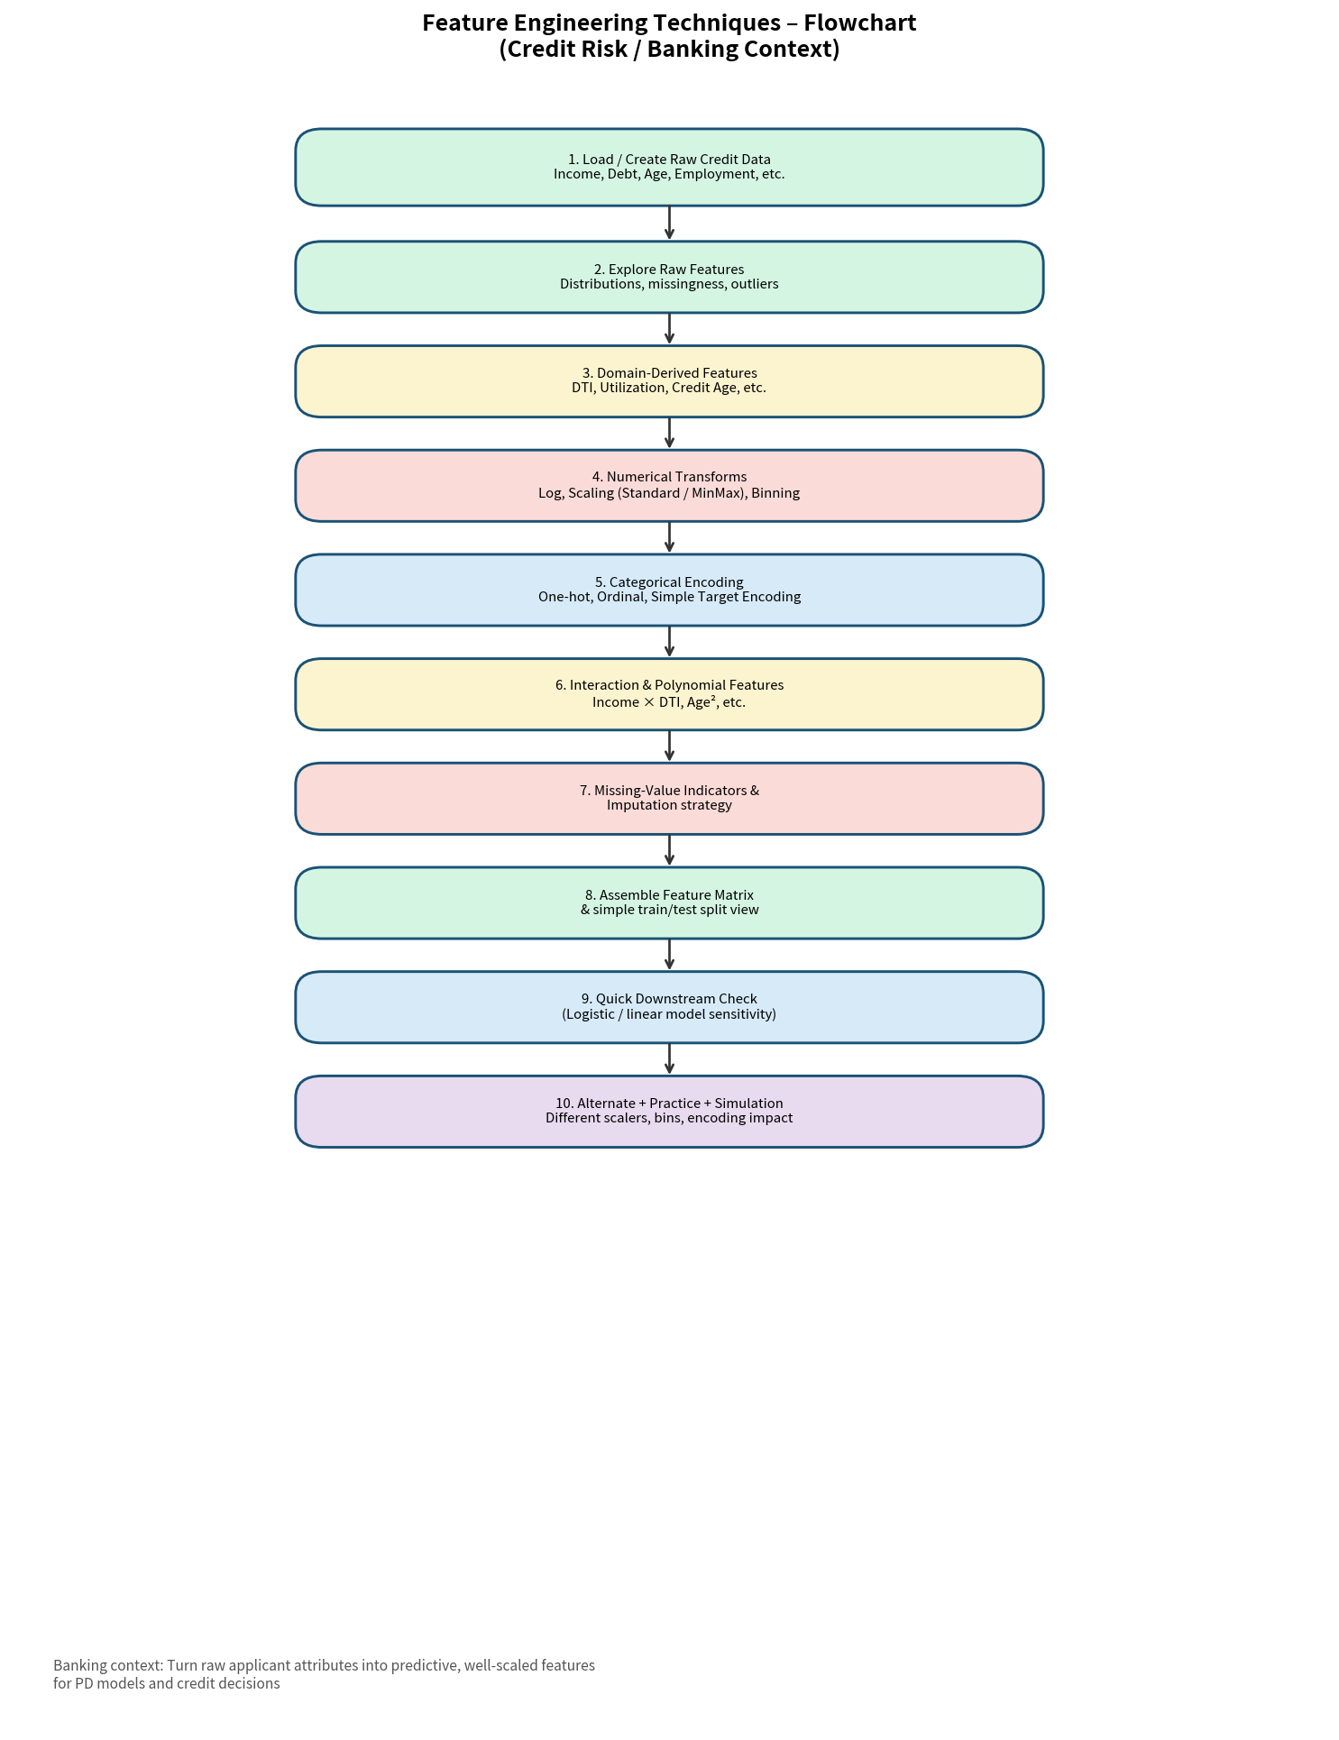
Figure 1 – Feature-engineering workflow
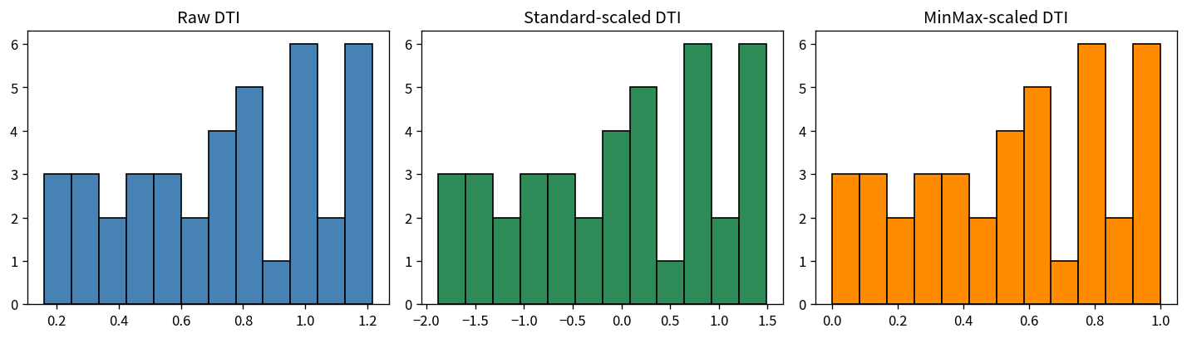
Figure 2 – Effect of Standard vs MinMax scaling on DTI
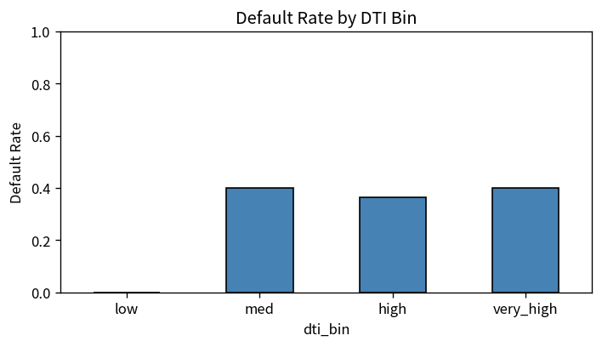
Figure 3 – Default rate by DTI bin (business-friendly view)

Key Takeaways
- Domain-derived ratios (DTI, utilisation) almost always outperform the raw dollar amounts that created them.
- Scaling is essential for distance-based and regularised linear models; binning is valuable for both modelling and business communication.
- Simple target encoding can be powerful but must be nested inside cross-validation to avoid leakage.
- Missing-value indicators often carry signal (the fact that a field is missing can itself be predictive).
- A short simulation of bin count / scaling choice quickly shows stakeholders how engineering decisions change risk segmentation.

